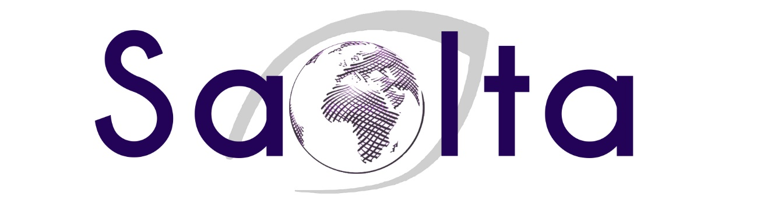

[Click here to enter a date]

Empowerment for a better world through adult and community education.

DEVELOPMENT EDUCATION EVALUATION TOOLKIT

SECTION 2 – Templates
- Workshop Evaluation
- Public Event Evaluation Survey
- Pre-Course Evaluation - Baseline
- In-Course Evaluation
- Post-Course Evaluation - Results

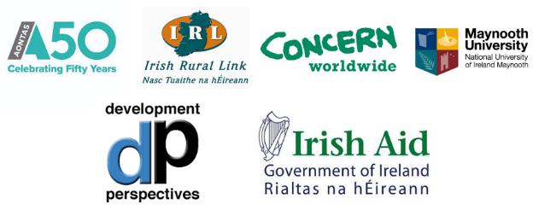
Section 2

Workshop Evaluation
Workshop: | Date:

Can you let us know a little about your understanding of issues we covered today? It will help us develop more effective learning opportunities in the future.

Please rate your level of knowledge of [insert desired outcome/result]:
Before workshop: [ ] Excellent [ ] Good [ ] Poor [ ] Don’t know
After workshop: [ ] Excellent [ ] Good [ ] Poor [ ] Don’t know

I have a good understanding of [insert desired outcome/result].
Before workshop: [ ] Strongly agree [ ] Agree [ ] Don’t know [ ] Disagree [ ] Strongly disagree
After workshop: [ ] Strongly agree [ ] Agree [ ] Don’t know [ ] Disagree [ ] Strongly disagree

I can think of concrete actions I can take to create a fairer and more sustainable world for everyone.
Before workshop: [ ] Strongly agree [ ] Agree [ ] Don’t know [ ] Disagree [ ] Strongly disagree
After workshop: [ ] Strongly agree [ ] Agree [ ] Don’t know [ ] Disagree [ ] Strongly disagree

What is your key take away from this workshop?
Please turn over!
Do you have any feedback on how to improve this workshop?

Would you like to learn more about [event topic]?
[ ] Yes [ ] Maybe [ ] No

Please write your email address here if you would like to be contacted about future events:
____________________________________________________________________________________
The following information is required by our funders, for monitoring and evaluation purposes. We would appreciate it if you would complete this table.
What is your gender? | [ ] Female [ ] Male [ ] Non-binary [ ] Prefer not to answer
What is your age range? | [ ] 15-24 years [ ] 25-44 years [ ] 45-64 years [ ] 65+ years  [ ] Prefer not to answer
What county do you live in? | County_________________________ / [ ] Prefer not to answer
What is your sector of work/study/interest? | _______________________________ / [ ] Prefer not to answer

Thank you from all the team for joining us for this workshop. We hope to connect in the future.

Public Event Evaluation - Survey
Thank you for coming to our event. We would be grateful if you would answer a few short questions so that we can improve on our work.
Please indicate how much you agree or disagree with each statement: | Strongly Disagree | Disagree | Don’t know | Agree | Strongly Agree
This event has improved my understanding of…….
This event has made me want to find out more about ……..
This event has inspired me to want to do something about ………..
What is your key take away from this event?
What could we do better?
How did you find out about this event?
The following information is required by our funders for monitoring and evaluation purposes. We would appreciate it if you would complete this table.
What is your gender? | [ ] Female [ ] Male [ ] Non-binary [ ] Prefer not to answer
What is your age range? | [ ] 15-24 years [ ] 25-44 years [ ] 45-64 years [ ] 65+ years  [ ] Prefer not to answer
What county do you live in? | County_________________________ / [ ] Prefer not to answer
What is your sector of work/study/interest? | _______________________________ / [ ] Prefer not to answer

Pre-Course Evaluation – Baseline
Thank you for enrolling in this course. We would like to gather some information from you before the course begins. This will help us improve how we do things.

1. What is your preferred name – the name you would like us to use during this course?

2. How did you hear about the course?

3. What is the main reason you are doing this course?

4. What do you hope to achieve from doing this course?

5. What prior experience do you have relating to Development Education (e.g. have you read any books or watched films? Have you volunteered or worked in this area? Have you completed other courses?

Please turn over!
 | Strongly Agree | Agree | Disagree | Strongly Disagree | Don’t know
I have a good understanding of global development issues.
I have a good understanding of the Sustainable Development Goals (SDGs) agenda.
I am familiar with Ireland’s role in implementing the SDGs.
I am aware of different development theories.
I am a critical thinker.
6. Knowledge and skills: please indicate how much you agree or disagree with the following statements.

7. Empowerment: please indicate how much you agree or disagree with the following statements.
 | Strongly Agree | Agree | Disagree | Strongly Disagree | Don’t know
I have the right knowledge to take action for a better world.
I have the right skills to take action for a better world.
I believe I can make the world a better place.
I am confident in my ability to make the world a better place.

8. Engagement: please indicate how much you agree or disagree with the following statements.
 | Strongly Agree | Agree | Disagree | Strongly Disagree | Don’t know
I can identify practical ways to take action.
I am actively involved in making the world a better place.

Thank you for your time!

In-Course Evaluation
This evaluation is designed to show us how you are getting on and if there are any areas that need improving. Please score each aspect using the following scale: 0 = Not at all 6 = Fully

Any other comments?

Post-Course Evaluation – Results
Thank you for participating in this course. We would like to gather some information from now that course has ended. This will help us improve what we do.

1. How did you find the way we work?

2. What did you enjoy most about the course?

3. What improvements could we make?

4. What did you find most effective?

Please turn over!
 | Strongly Agree | Agree | Disagree | Strongly Disagree | Don’t know
I have a good understanding of global development issues.
I have a good understanding of the Sustainable Development Goals (SDGs) agenda.
I am familiar with Ireland’s role in implementing the SDGs.
I am aware of different development theories.
I am a critical thinker.
5. Knowledge and skills: please indicate how much you agree or disagree with the following statements.
 | Strongly Agree | Agree | Disagree | Strongly Disagree | Don’t know
I have the right knowledge to take action for a better world.
I have the right skills to take action for a better world.
I believe I can make the world a better place.
I am confident in my ability to make the world a better place.
7. Empowerment: please indicate how much you agree or disagree with the following statements.

8. Engagement: please indicate how much you agree or disagree with the following statements.
 | Strongly Agree | Agree | Disagree | Strongly Disagree | Don’t know
I can identify practical ways to take action.
I am actively involved in making the world a better place.

Thank you for your time!

